Business Question and Visualization Report

Date | 18 September 2026
Team ID | MCA
Project Name | Online learning Engagement and Student Performance Analysis
Maximum Marks | 5 Marks

Visualization development for the Online Education Analytics Dashboard focuses on converting student-related data into simple and meaningful visual representations. The dashboard presents information about student performance, engagement levels, final results, and dropout rates using different charts and KPI cards. Interactive filters allow users to view and compare data based on different student categories. These visualizations make it easier to identify patterns, understand student outcomes, and analysed the overall performance of the online education system.
Business Questions and Visualisation
The process involves identifying important business questions about students, their engagement, performance, and final results. These questions help in creating useful visualizations in Power BI. Clear questions make it easier to select the right data, measures, and charts. The visualizations help to understand the data and find important patterns and insights.
What is the distribution of total students across regions? | Bar chart showing total student count by region. | 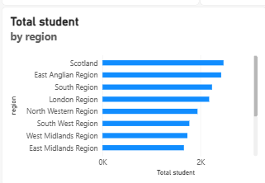
 | Donut chart showing total students by final result | 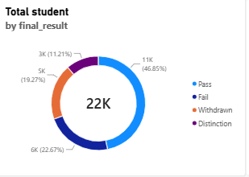
  How are students distributed by final result?
 | Column chart comparing average total clicks by engagement level. | 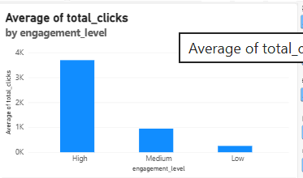
  How does average total clicks vary by engagement level?
How does average score vary by engagement level? | Column chart comparing average score by engagement level. | 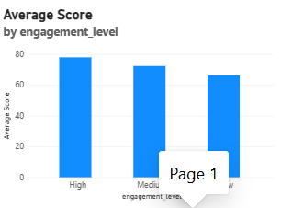
How does average score vary by performance level? | Column chart comparing average score by performance level. | 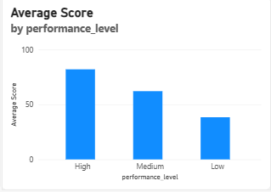
How are students distributed by performance level? | Donut chart showing total students by performance level. | 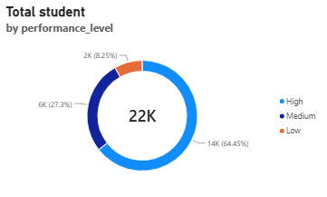
How does Average Score vary across different regions? | Column chart comparing Average Score by region | 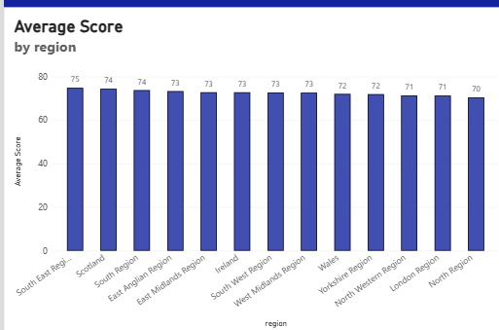
How are students distributed according to their risk level? | Donut chart showing total students by risk level. | 